An HR scorecard visually represents the critical measures of the HR department's achievements, productivity levels, and other parameters - critical to the company's growth.

Most HR scorecards are tied to strategic plans and are designed to track and measure the efficacy of HR activities, enabling the leadership to make targeted investments in HR. Scorecards include current data and comparisons with previous periods.

It is true when HR consultant and I/O psychologist Rob Silzer said, "Financial resources may be the lifeblood of a company, but human resources are the brains."

Traditionally HR was viewed as a support function that undertook basic tasks such as payroll, time tracking, and disputes between the organizations and unions. The role of the erstwhile personnel manager evolved into the HR we know today with the advent of the services sector.

With a scorecard, HR leaders can assess the department's performance in their way and within a set structure that can be understood across the organization. Here are the top four benefits of an HR balanced scorecard:

1.2 PURPOSE

**1. Gives structure to the strategy**

A scorecard helps keep the goals at the center, uses specific parameters to track progress, and follows initiatives for monitoring actions.

### 2. Improves performance reporting

The HR scorecard can come in handy for designing performance reports and dashboards, ensuring the focus remains on critical strategic issues and helping the HR department monitor the execution of its plan.

### 3. Makes it easier to communicate the strategy

Having a scorecard takes the guesswork out of trying to understand everyone's responsibilities in the team and gets the entire department synced up under one structure. This also gives a much clearer picture of HR projects and initiatives.

2.PROBLEM DEFINITION& DESIGN THINKING

2.1 EMPATHY MAP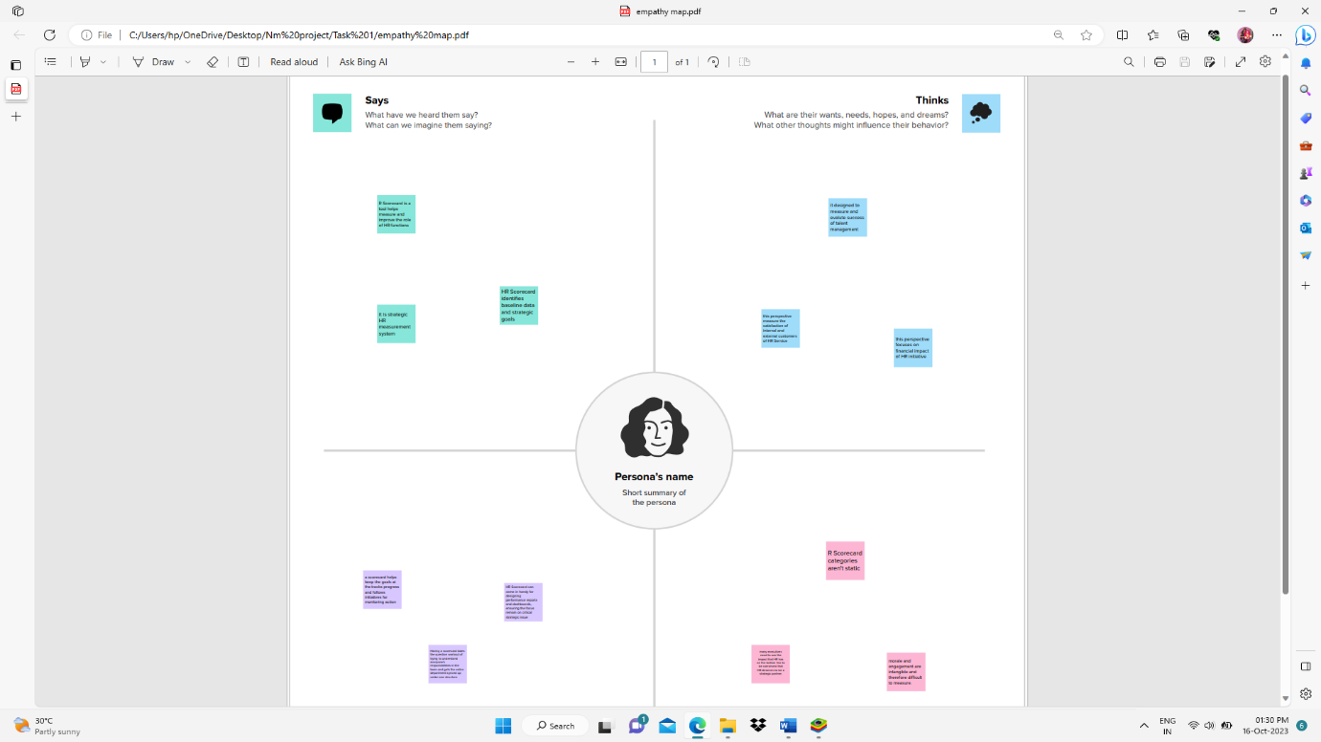

2.2 BRAINSTROMING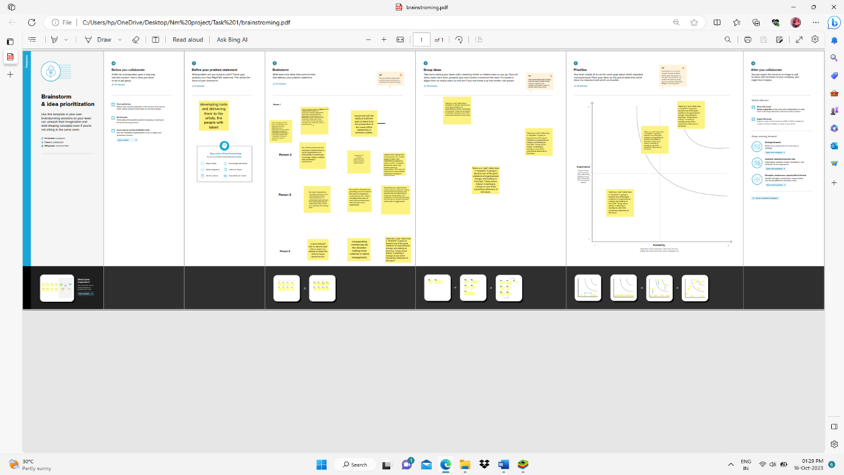

3.RESULT

DASHBOARD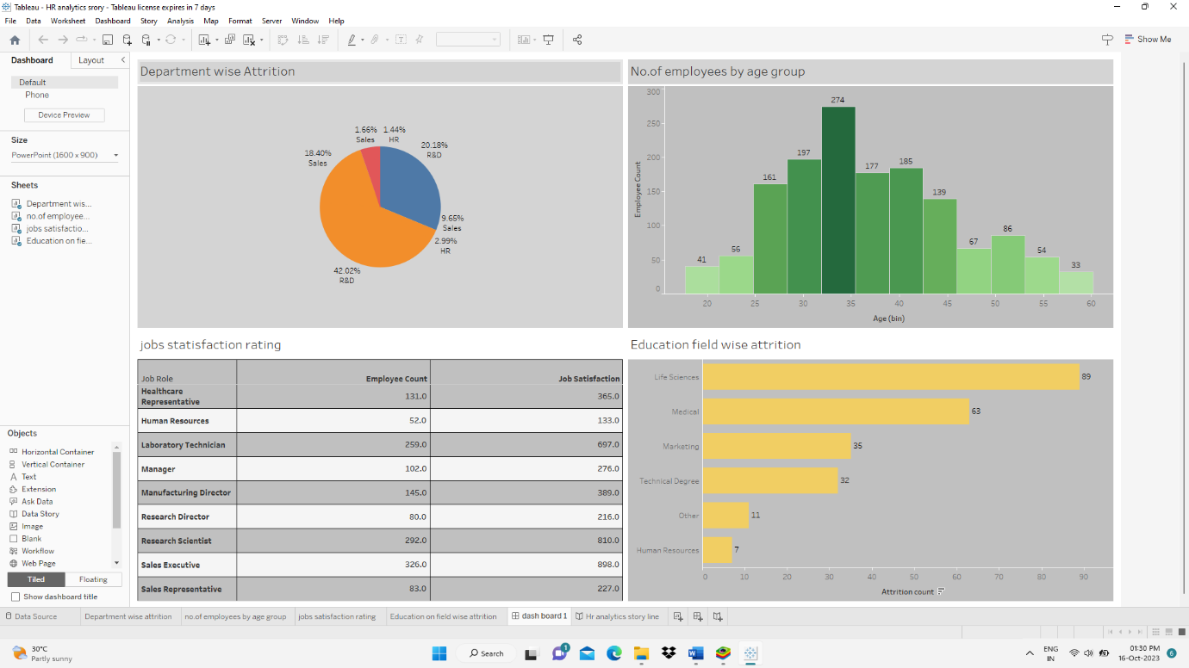

STORY LINE

1.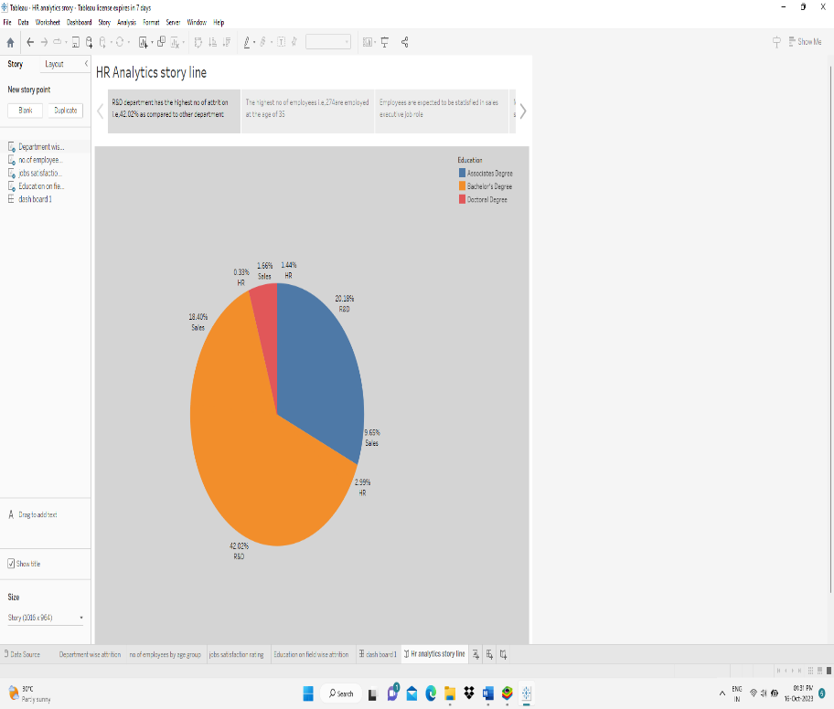

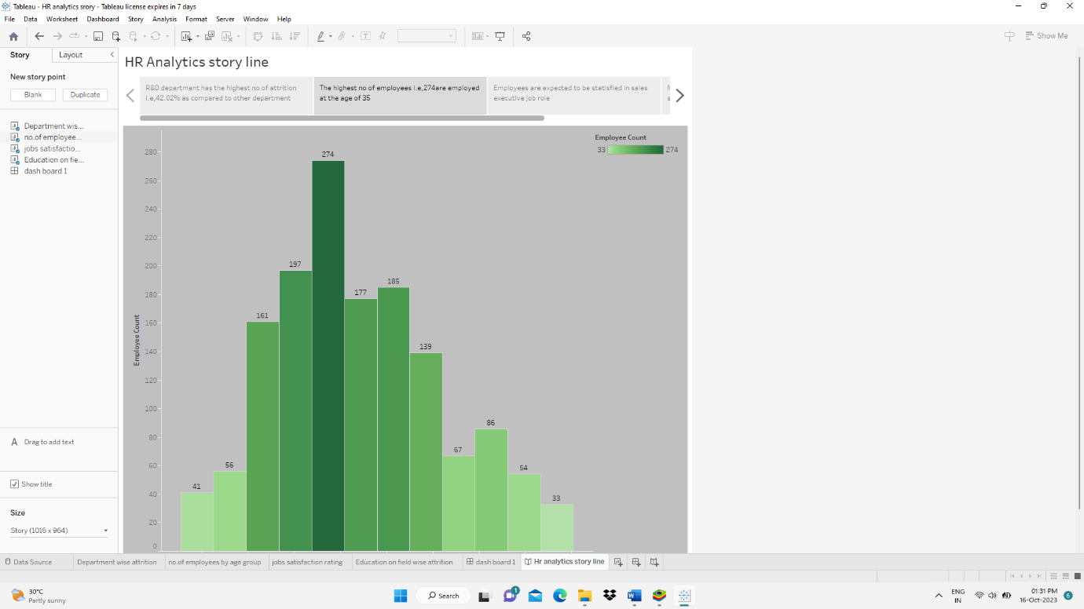

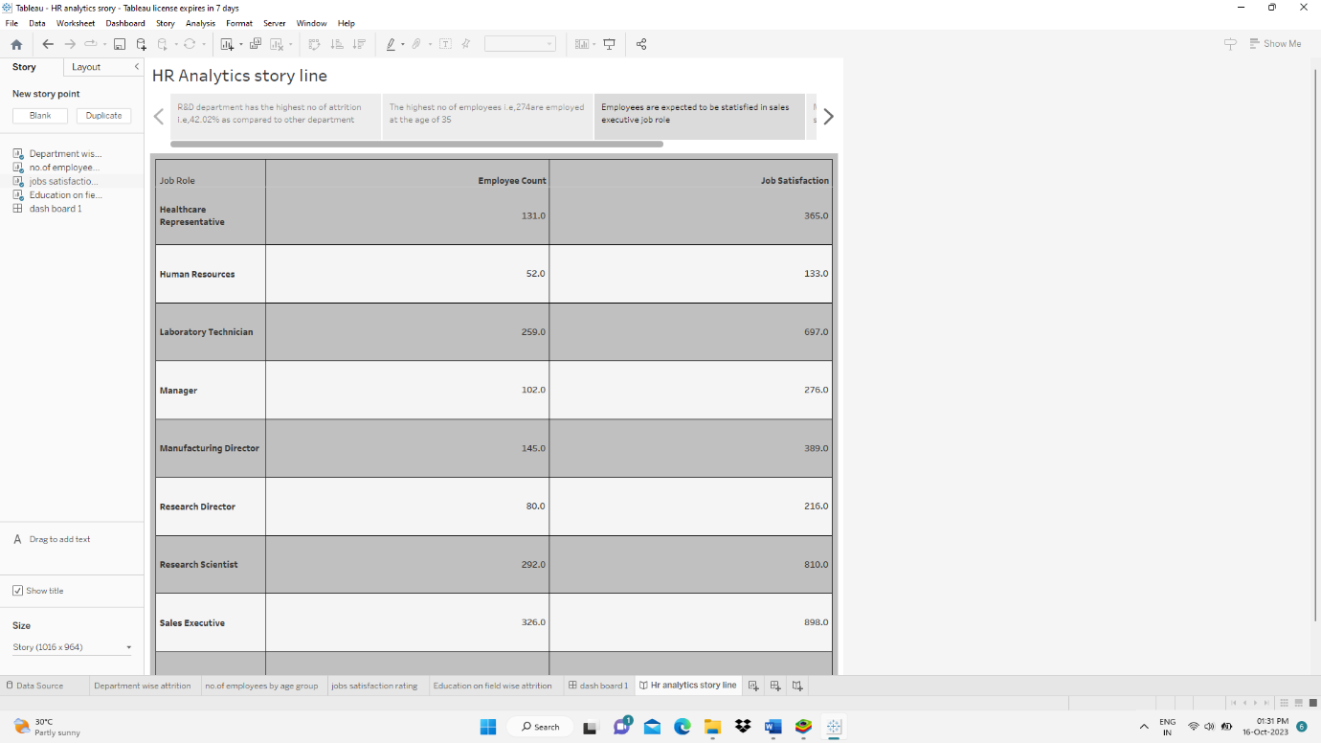

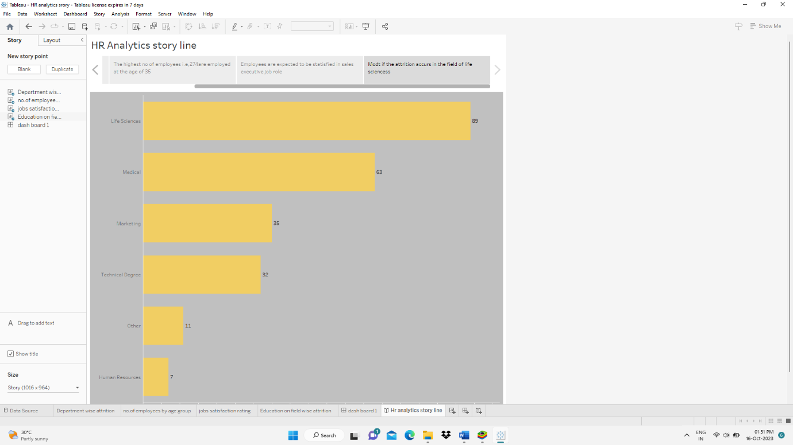

4.ADVANTAGES AND DISADVANTAGES

4.1 DISADVANTAGES

### It can be an overwhelming framework.

After five books and countless articles, the sheer amount of material on the Balanced Scorecard is a bit mind-boggling. In fact, it’s the largest topic on the [**Harvard Business Review**](https://hbr.org/topic/balanced-scorecard) website—and if you tried to read every single case study, you’d get bogged down quickly. Additionally, if you try to jump in with with Norton and Kaplan’s fifth book, you’re likely to get overwhelmed with how to move forward.

4.2 ADVANTAGE

### It gives structure to your strategy.

Unlike financial or HR management, organizations frequently talk about organizational performance (and strategy) in a variety of ways. Thus, there are many different approaches to strategic management. The Balanced Scorecard is a logical, structured way to help the leaders of your organization ensure that all areas of the organization are covered in an easy-to-understand way. It helps keep your goals at the center, uses specific measurements to track progress, and follows initiatives to track actions—a structure those who use the BSC know and love.

5.APPLICATION

Your HR mission or vision is separate from that of the organization, and should be used to highlight the key focus of your department. For example:

“We want to provide the highest-skilled employees for all our business departments and support a culture of collaboration between each department and all employees.”

**6.CONCLUSION**

if you’re looking at the Balanced Scorecard as the solution to all of your problems, **be aware that organizations implement the BSC in different ways**. Carefully take into consideration the way your leadership team operates to be certain you move into the BSC at an appropriate pace.